Re-flashing MPx200

This procedure will re-flash your phone to any firmware file. It will not back up any previous firmware version. Be 100% sure to save your personal data before proceeding as it will wipe the phone clean! This procedure is not reversible. To go back to a previous firmware version requires having a copy of the previous version and following this procedure again to install it.

Unzip the PCUpgradeWizard file to your hard drive

Double click the setup file (setup.exe) and follow the instruction to install the PCUpgradeWizard Package.

Installation of USB driver for Handset

Unzip the driver file to your hard drive (smartfon.inf) from Compass

Power off the phone.

Hold the left direction key.
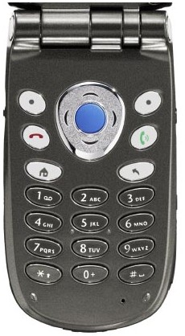

Plug in the USB cable.
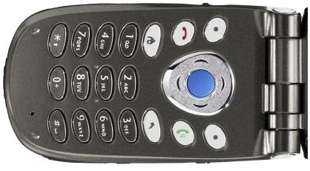

Windows 2000 should launch a splash which indicates that a new USB device is found.
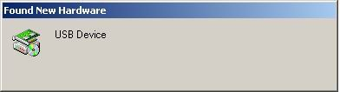
Then a hardware wizard is launched.
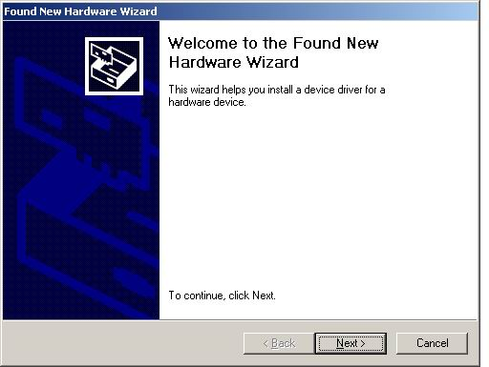
Press Next to continue.

Search for a suitable driver and press next button.
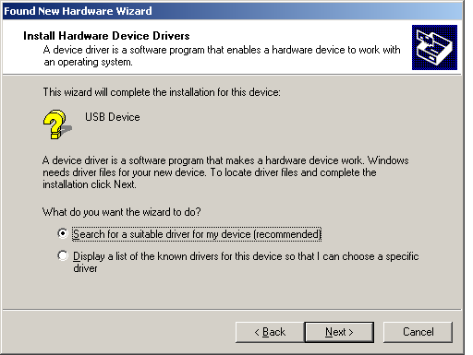
Check “Specify a location” and press Next.
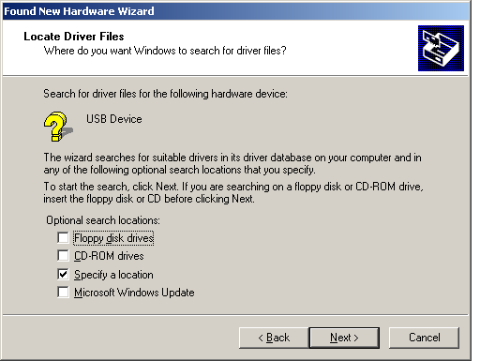

Browse and select smartfon.inf from where you saved the file on your hard drive to install Smartphone 2002 Wireless Modem driver.
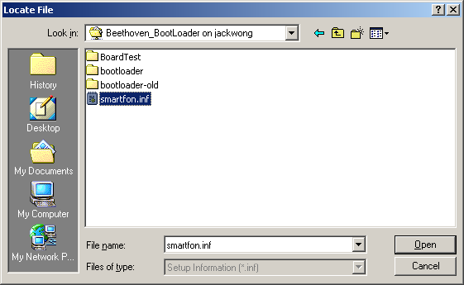
Press Yes to continue the install.
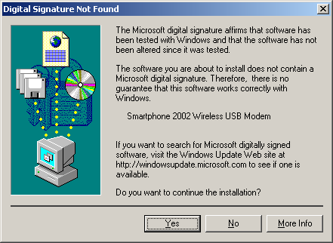
Finally check the computer manager, and a Smartphone 2002 Wireless Modem should appears in Modems. 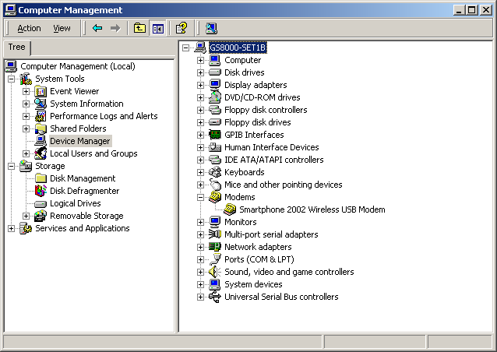

Down load the new software

Unzip the latest s/w file (such as: BEN5-0400-012.bin)

Save this file to your hard disk

Starting PC UpgrageWizard

Simply execute the PC UpgradeWizard file from your Programs Menu

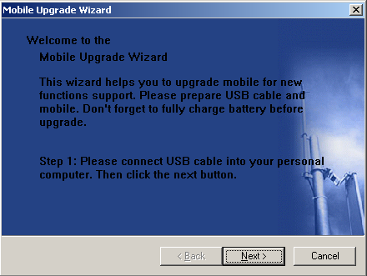

Follow the menus

Once complete – unplug your phone

Done

